Name: Pranali Sonawane
Subject: CCNA
Date:
Lab – HSRP(Hot standby Router Protocol) with active-backup:
First, we have taken one switch, two PCs, and two routers. The PCs are connected to the switch using straight-through cables. The routers are also connected to the switch using straight-through cables.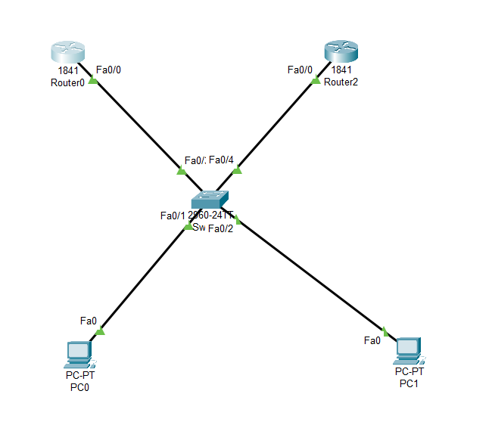
Open Switch 0 – CLI prompt then type following commands
Switch>enable
Switch#config terminal
For VLAN 10 :
Switch (config)#vlan 10
Switch (config-vlan)# name CCNA
Switch (config-vlan)#exit

Switch (config)#interface fastEthernet 0/1
Switch (config-if)#switchport mode access
Switch (config-if)#switchport access vlan 10
Switch (config-if)#exit

For VLAN 20 :
Switch (config)#vlan 20
Switch (config-vlan)#name MCSA
Switch (config-vlan)#exit

Switch (config)#interface fastEthernet 0/2
Switch (config-if)#switchport mode access
Switch (config-if)#switchport access vlan 20
Switch(config-if)#exit

Switch (config)#interface fastEthernet 0/3
Switch (config-if)#switchport mode access
Switch (config-if)#switchport access vlan 10
Switch(config-if)#exit

Switch (config)#interface fastEthernet 0/4
Switch (config-if)#switchport mode access
Switch (config-if)#switchport access vlan 20
Switch(config-if)#exit
Open Router 0 – CLI prompt then type following commands
Router>enable
Router#configure terminal
Router(config)# interface fastEthernet 0/0.10
Router(config-subif)# encapsulation dot1Q 10
Router(config-subif)# ip address 10.0.0.3 255.0.0.0
Router(config-subif)# exit

Router(config)# interface fastEthernet 0/0.20
Router(config-subif)# encapsulation dot1Q 20
Router(config-subif)# ip address 20.0.0.3 255.0.0.0
Router(config-subif)# exit

Router(config)# interface fastEthernet 0/0.10
Router(config-subif)#standby 1 ip 10.0.0.10
Router(config-subif)#standby 1 priority 90
Router(config-subif)#standby 1 pre-empt
Router(config-subif)#exit
Router(config)# interface fastEthernet 0/0.20
Router(config-subif)#standby 2 ip 20.0.0.10
Router(config-subif)#standby 2 priority 120
Router(config-subif)#standby 2 pre-empt
Router(config-subif)#exit
Router(config-if)#ip dhcp pool VLAN10_R2
Router(dhcp-config)#network 10.0.0.0 255.0.0.0
Router(dhcp-config)#default-router 10.0.0.10
Router(dhcp-config)#exit
Router(config-if)#ip dhcp pool VLAN20_R2
Router(dhcp-config)#network 20.0.0.0 255.0.0.0
Router(dhcp-config)#default-router 20.0.0.10
Router(dhcp-config)#exit
Router(config)# interface fastEthernet 0/0
Router(config-if)#no sh

Router(config)# exit
Router# show standby brief

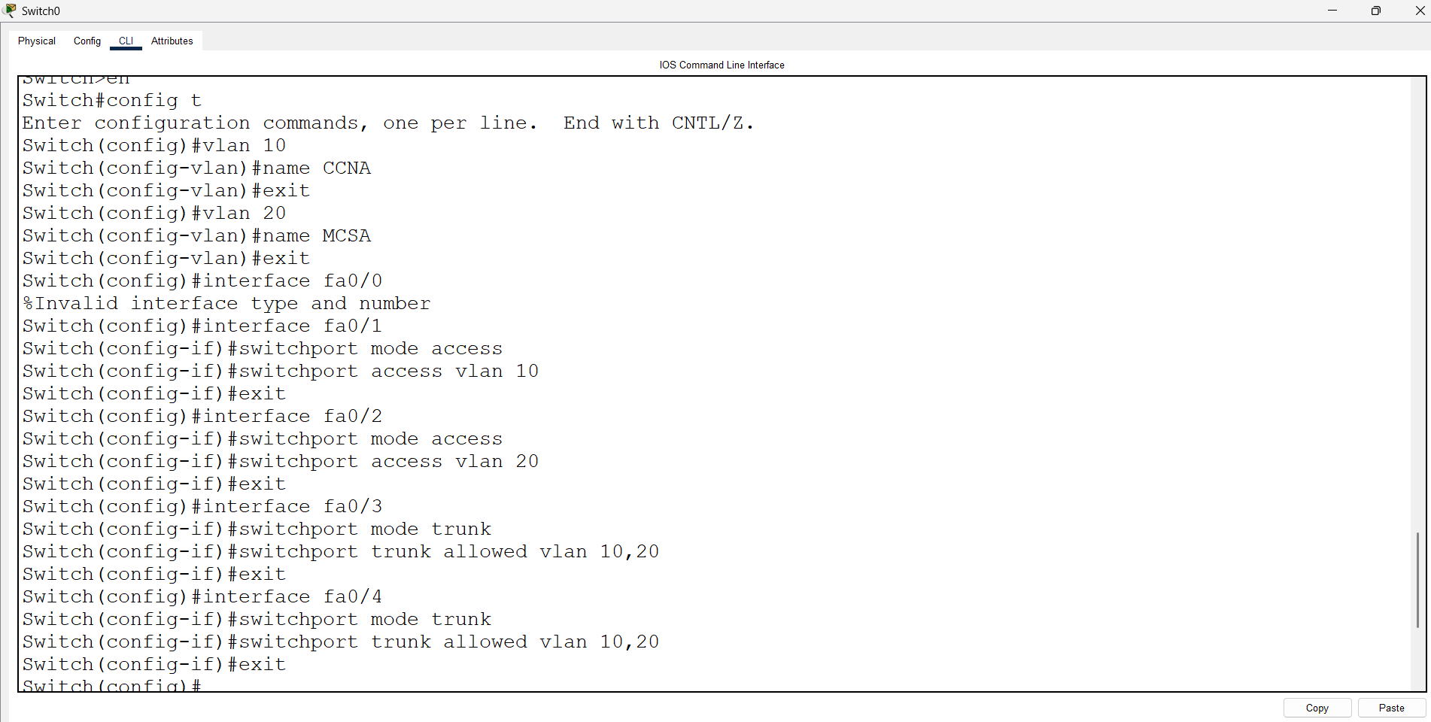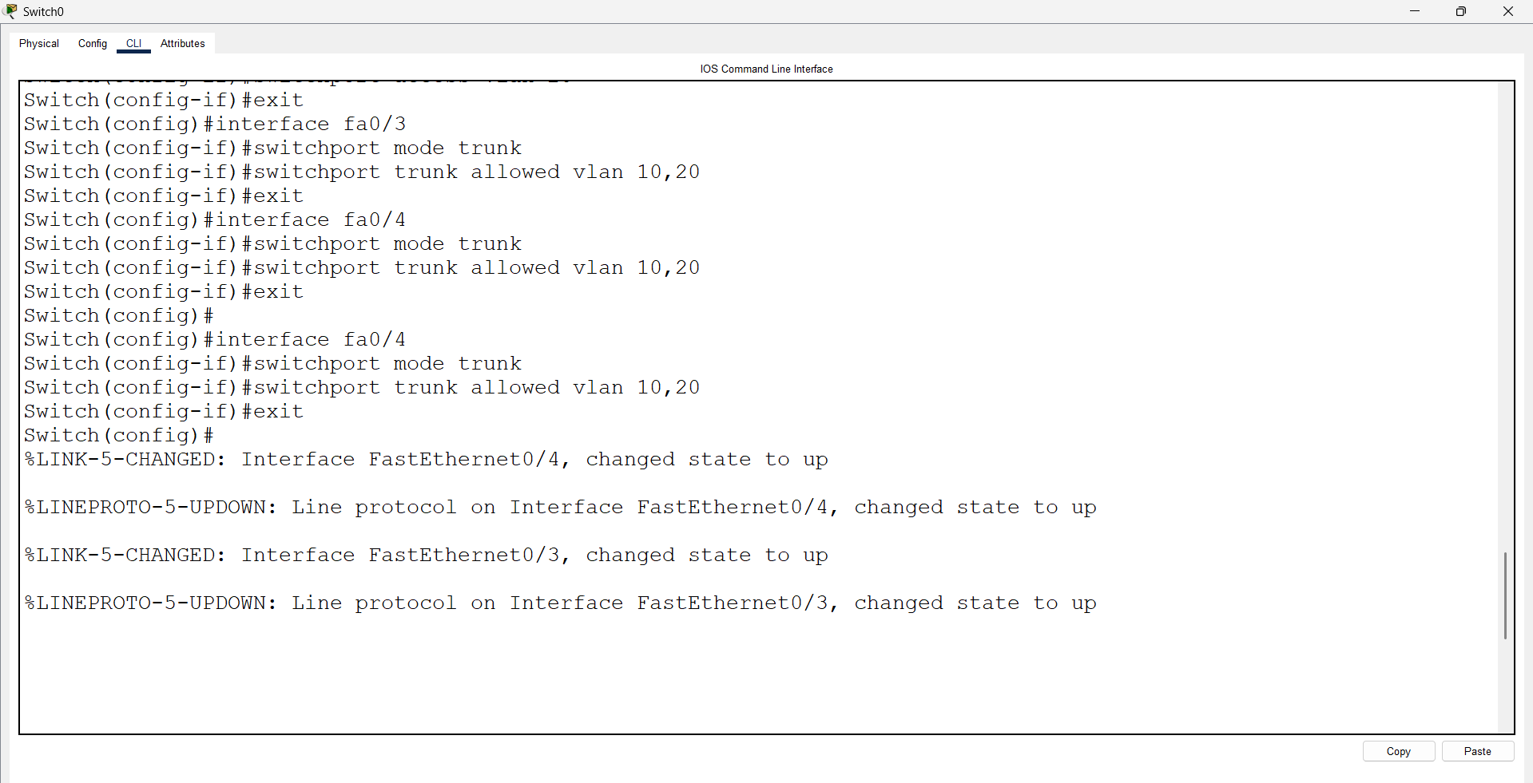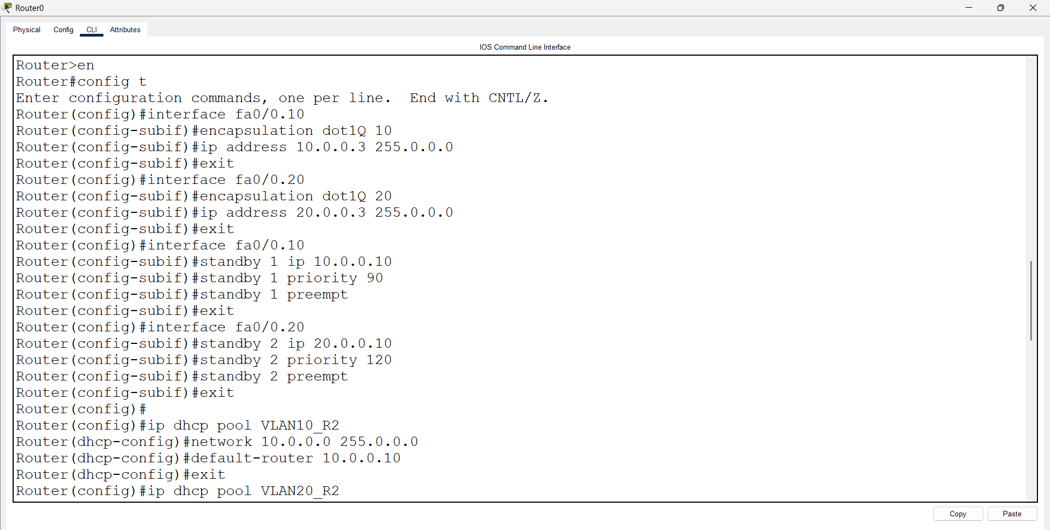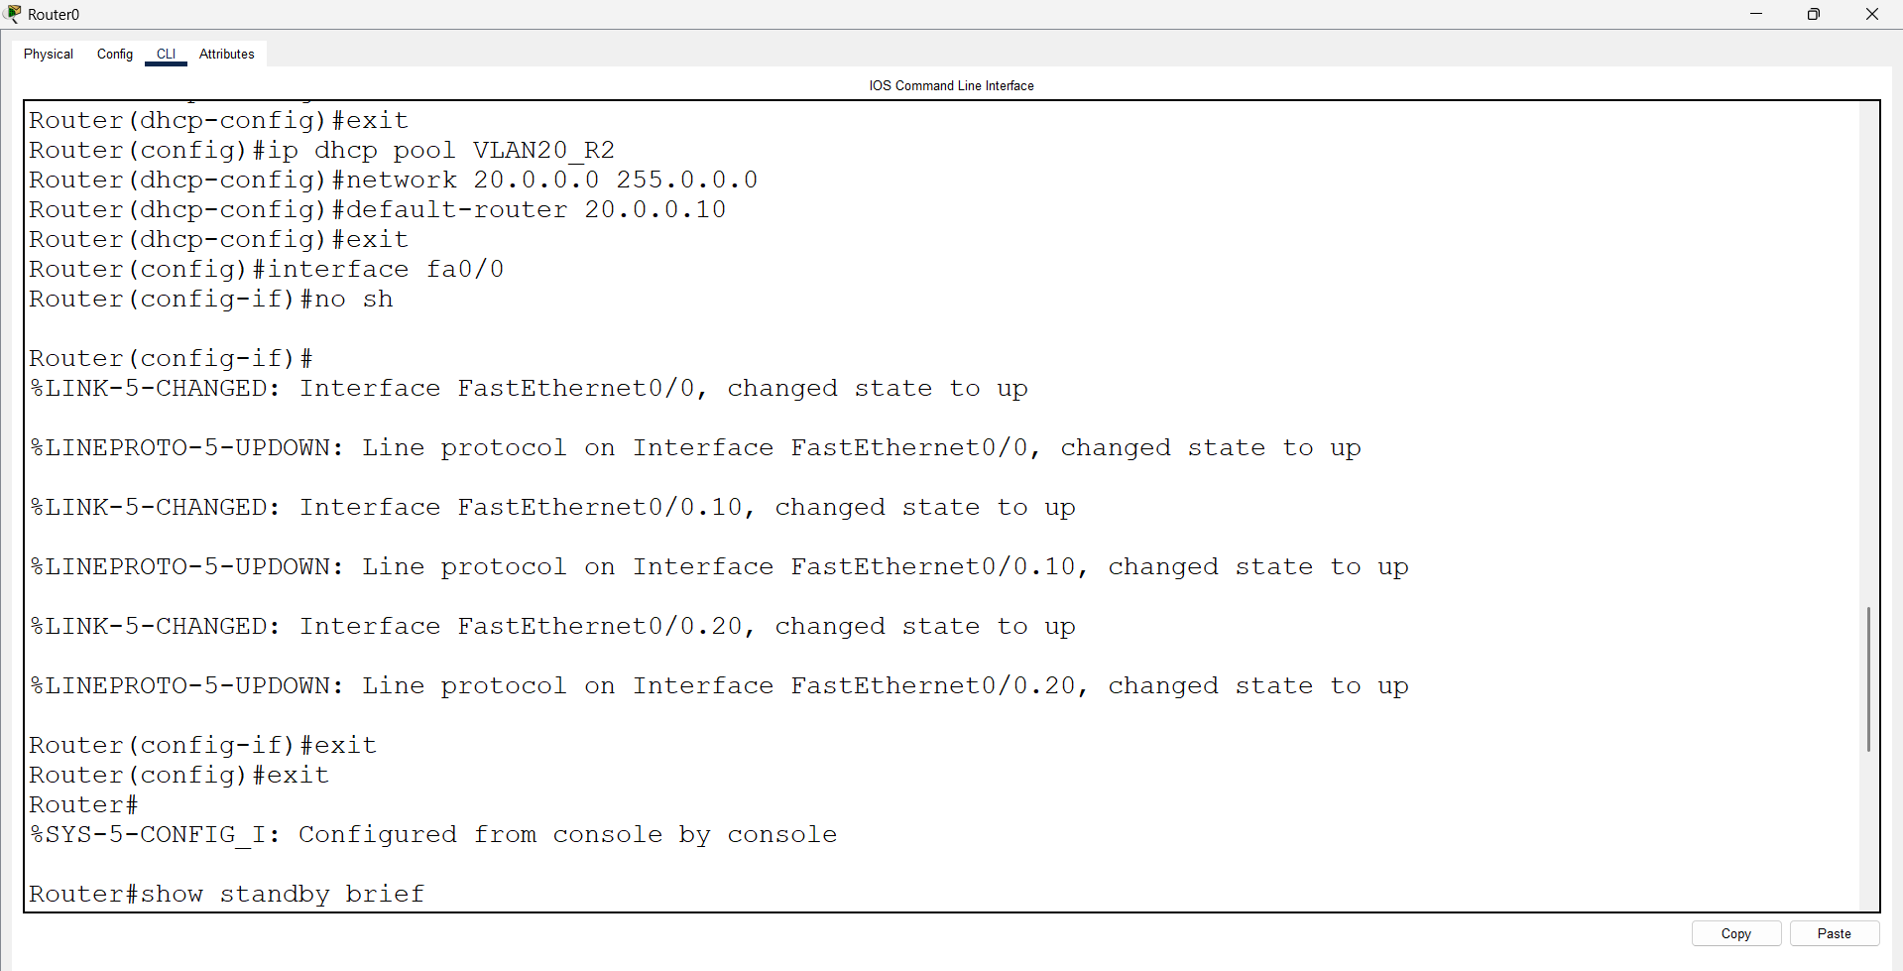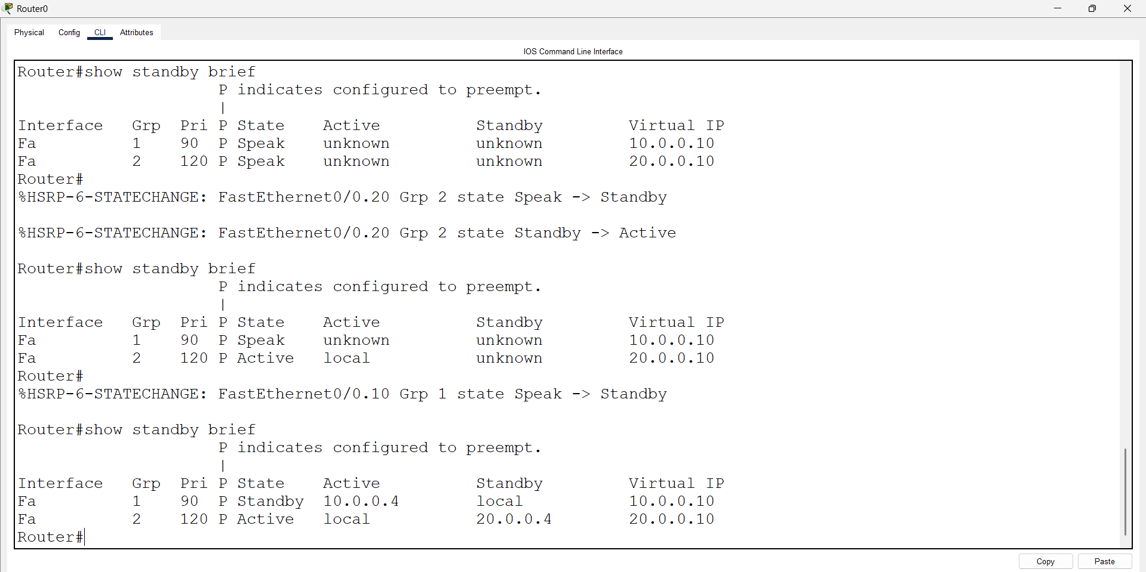
Open Router 1 – CLI prompt then type following commands
Router>enable
Router#configure terminal
Router(config)# interface fastEthernet 0/0.10
Router(config-subif)# encapsulation dot1Q 10
Router(config-subif)# ip address 10.0.0.4 255.0.0.0
Router(config-subif)#standby 1 ip 10.0.0.10
Router(config-subif)#standby 1 priority 120
Router(config-subif)#standby 1 pre-empt
Router(config-subif)#exit
Router(config)# interface fastEthernet 0/0.20
Router(config-subif)# encapsulation dot1Q 20
Router(config-subif)# ip address 20.0.0.3 255.0.0.0
Router(config-subif)#standby 2 ip 20.0.0.10
Router(config-subif)#standby 2 priority 90
Router(config-subif)#standby 2 pre-empt
Router(config-subif)#exit
Router(config)#ip dhcp pool VLAN10_R1
Router(dhcp-config)#network 10.0.0.0 255.0.0.0
Router(dhcp-config)#default-router 10.0.0.10
Router(dhcp-config)#exit
Router(config)#ip dhcp pool VLAN20_R1
Router(dhcp-config)#network 20.0.0.0 255.0.0.0
Router(dhcp-config)#default-router 20.0.0.10
Router(dhcp-config)#exit
Router(config)# interface fastEthernet 0/0
Router(config-if)#no sh
Router(config)# exit
Router# show standby brief
